**Preview 03**

**Superposition theorem and homogeneity theorem**

A Report By

***Kibria Golam***

***2019380163***

**1．Under what condition does the homogeneity theorem not hold true?**

**Describe two possibilities: 1) we need to replace element 2) we don’t need to replace elements to satisfy homogeneity, design an experiment to prove that.**

Under non liner condition homogeneity theorem does not hold true.

1. We need to change the non-linear element (in this case, it’s a diode) with something that is linear.

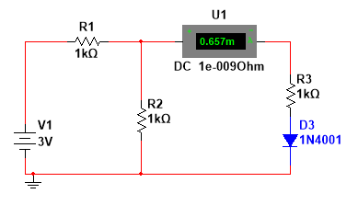 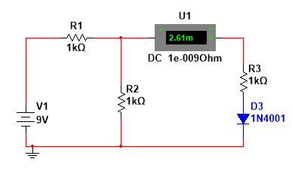

From the circuits above its is evident that if we use non linear item in the circuit the current flow will not be linear even though we change the source voltage source.

Here we change the voltage source 3times but the current flow doesn’t change 3times.

One way to make the circuit linear is to replace the non-linear item (the diode).

1. We can also make the same circuit linear by shorting the diode without replacing it.

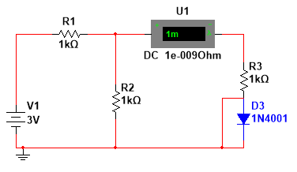 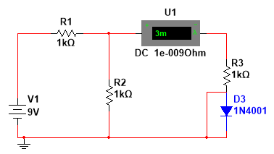

From the circuit above we can see shorting the diode changes the non linear circuit into a linear circuit; no need to replace element. As the current flowing through the R3 has become directly proportional to the source voltage.

**2． Under what condition does the superposition theorem not hold true? Describe two possibilities: 1) we need to replace element 2) we don’t need to replace elements to satisfy homogeneity, design an experiment to prove that.**

Super position theorem doesn’t work on non linear circuit.

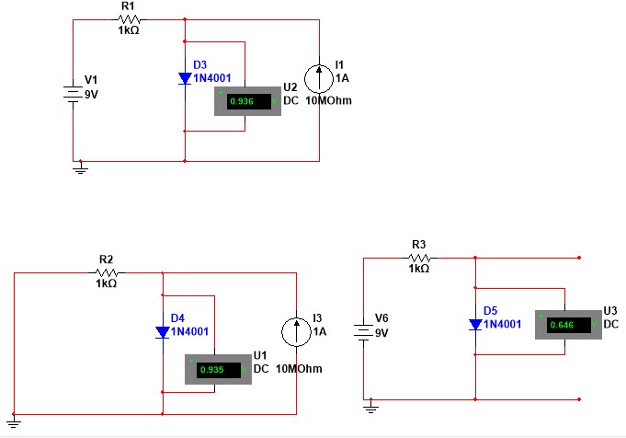

If we sum up the last two circuit’s voltage, it doesn’t equal to the 1st circuit’s voltage.

**3． List the reasons of the inaccuracy of the experiment data. How to guarantee the accuracy of experiment? Elaborate your methods and use them in your design.**

Unfortunately, this student is unable to answer this question.